For Immediate Release

Healing Springs Wellness Center Introduces The Grand Opening of their Newest Location

The Healing Springs Wellness Center is proud to announce the opening of its newest location, which offers exceptional services and amenities.

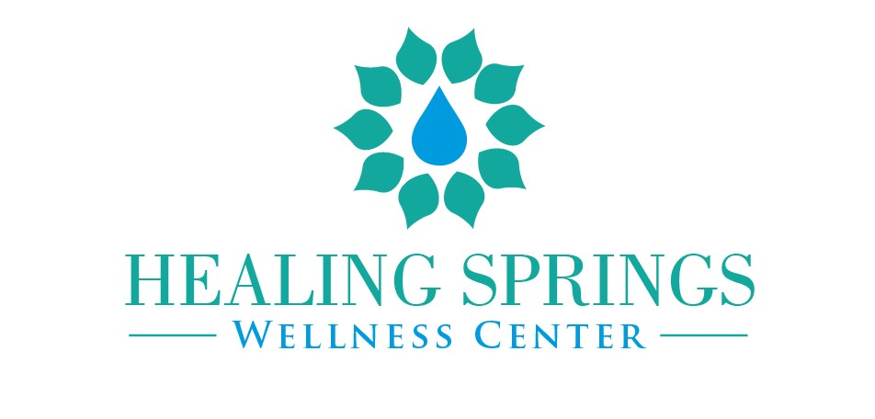

August 19, 2022, CONNECTICUT, United States of America— Healing Springs Wellness Center is excited to announce the opening of its new location on September 10, 2022. This new location provides a safe space for people of color to heal and promote wellness. To celebrate its grand opening, Healing Springs Wellness Center will host a free community event that includes refreshments, reiki sessions, giveaways and guest speakers. The event will be held at 1006 South Main Street, 2nd Floor, Plantsville, CT. 06479 (across from John F. Kennedy Middle School).

Healing Springs Wellness is a Connecticut-based company that provides in-person and online mental health therapy, nutritional counseling, holistic wellness services, and various groups and workshops for women, men, and college students. They provide services addressing their clients' minds, bodies, and spirits. Healing Springs Wellness' philosophy is that healing is about more than just treating the symptoms; it is about treating the entire person and changing their life for the better.

The center strongly believes everyone should have access to mental healthcare and wellness services. As such, Healing Springs is committed to providing quality services at an affordable price, and we're always happy to help those in need. Furthermore, at the grand opening, proceeds from the raffle prize giveaways will give scholarships to clients to attend therapy groups and workshops. In addition to providing high-quality services and affordable prices, Healing Springs prioritizes giving back to their community and supporting organizations dedicated to improving the lives of people in need.

With a highly competent team of ten therapists and wellness professionals the center aims to empower clients to reach their full potential and lead healthy, fulfilling lives. They believe true healing occurs when their clients feel safe and respected in an environment that is welcoming and inclusive of all cultures, genders, sexual orientations, races, and religions. Healing Springs offers an integrative approach to healing that combines traditional psychotherapy techniques with complementary therapies such as massage, acupuncture, and nutrition counseling.
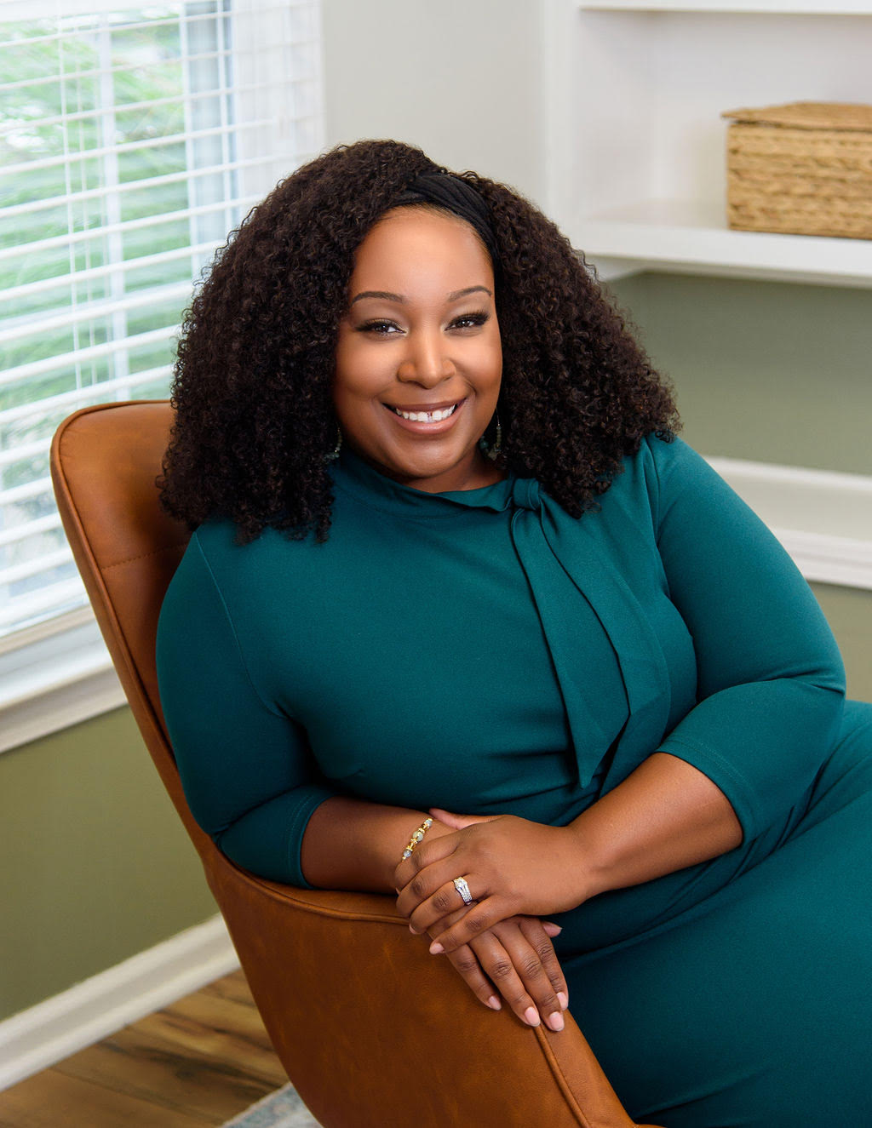
Recently, Healing Springs Wellness' owner Shawniel Chamanlal received the award for leadership in the Well-Being/Wellness category at the 20th Annual Health Care & Life Sciences Award Ceremony. This honor was granted due to her business's approach to mental health, aptly described when she said, "It's not just mental health, but integrated culturally competent trauma-informed care."

For more information about Healing Springs Wellness and its grand opening, please visit healingspringswellness.com or their social media accounts (Healing Springs Wellness, Shawniel Chamanlal, LinkedIn).

